R.O.P DATA COLLECTION FORM LGH, LHR
Patient ID # |  |  |  | Age at admission
Baby Name/ Gender | /Parents Name |  |  | Surfactant given  (Yes/No)
D. O. Admission  (dd-mm-yy) |  |  |  | Nasal  Oxygen CPAP  ^{Vent}
Birth Wt. (grams) |  |  |  | Average O₂Saturation
Gestational Age (wks) |  |  |  | Mechanical ventilation (days) O₂
D.O.B (dd-mm-yy) |  |  |  | Nasal CPAP (days)
Corrected Gestational age at D.O.D |  |  |  | Oxygen Protocol followed  (Y/N)
Weight at D.O.D  (grams) |  |  |  | D. O. Discharge  (dd-mm-yy)
Contact # |  |  |  | Day of life at D.O.D
Complete  address |  |  |  | Duration of stay in Hospital
Established Diagnosis of R.O.P  Zone/Stage/Plus |  |  |  | Treatment  (If any)
Date: | 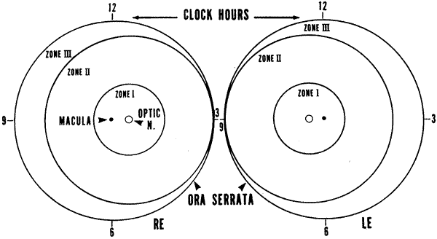
Age of patient
DOB

Next Visit:

Examiner: | Zone: | Stage: | Preplus: |  | Y / N | Zone: | Stage: |  | Preplus: | Y / N
 |  |  | Plus: |  | Y / N |  |  |  | Plus: | Y / N
Comments:

Date:

Age of patient
DOB

Next Visit:

Examiner: | Zone: | Stage: | Preplus: |  |  | Y / N |  | Zone: | Stage: |  |  | Preplus: | Y / N
 |  |  | Plus: |  |  | Y / N |  |  |  |  |  | Plus: | Y / N
Comments:

Date:

Age of patient
DOB

Next Visit:

Examiner: | Zone: | Stage: |  | Preplus: | Y / N |  | Zone: |  |  | Stage: | Preplus: |  |  | Y / N
 |  |  |  | Plus: | Y / N |  |  |  |  |  | Plus: |  |  | Y / N
Comments:

